**Variant #1 (Current Baseline):**

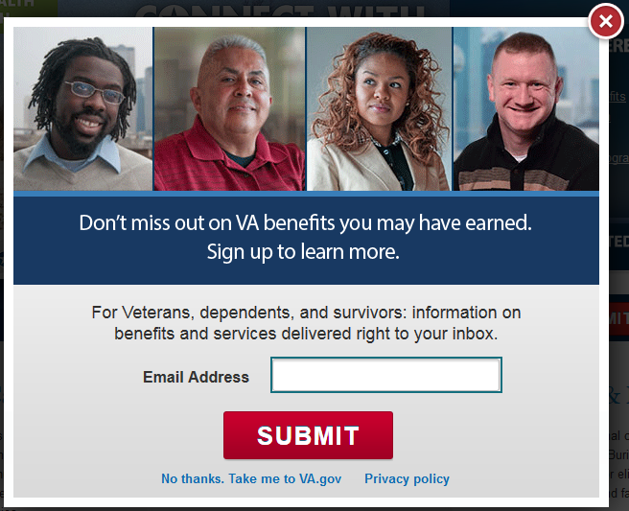

Variants #2 through 8 (below) each have **one change** relative to the baseline design.

**Variant #2 (no image):**

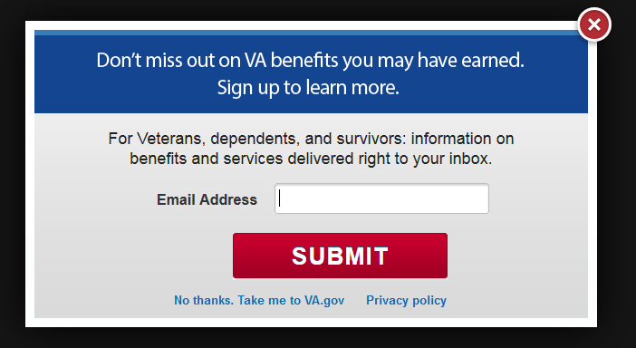

**Variant #3 (old image of 3 veterans):**

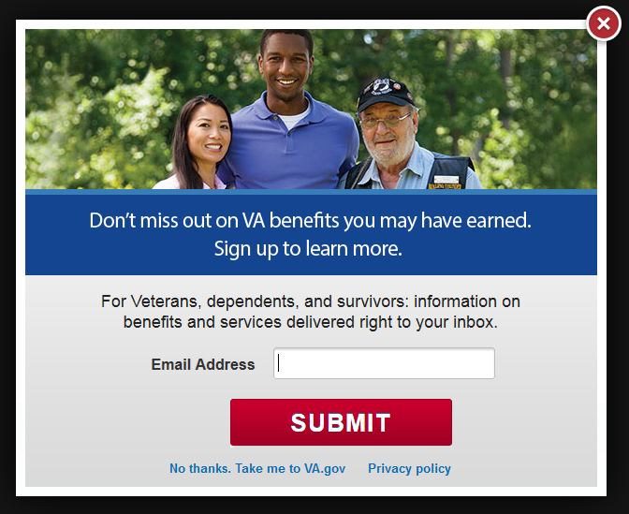

**Variant #4 (button text is “Get Updates” instead of “Submit”):**

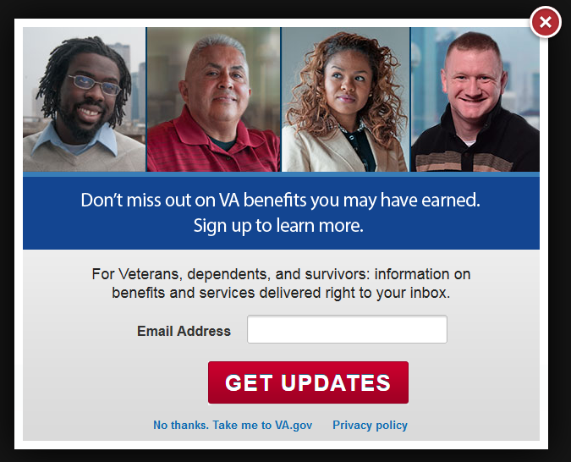

**Variant #5 (Headline text change):**

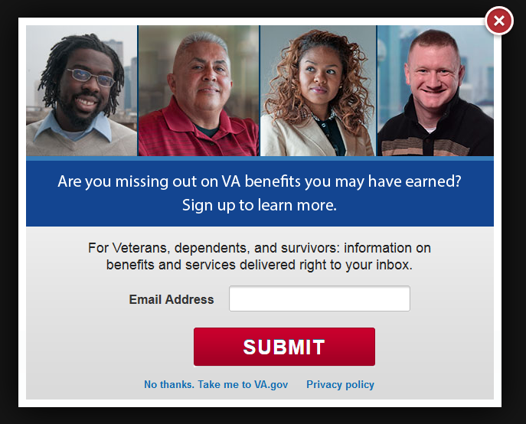

**Variant #6 (Helper text – short):**

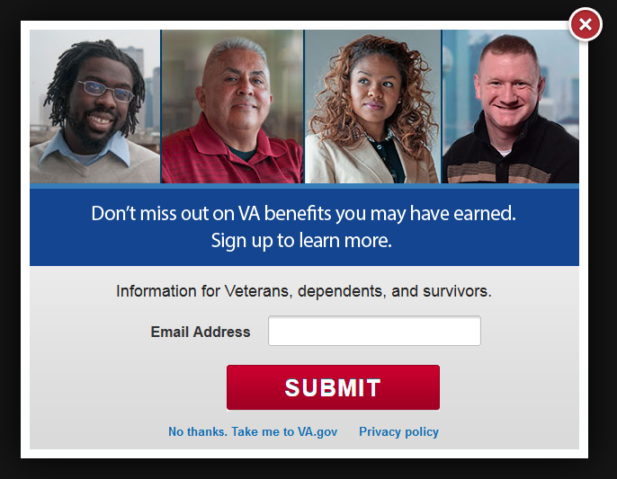

**Variant #7 (Helper text – alternate):**

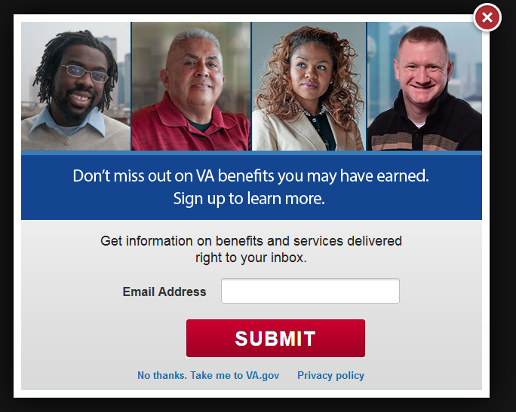

**Variant #8 (Headline text– “…may be eligible for” instead of “…may have earned”):**

